### 3.5.2 Data Exploration and Variable selection

The data was then imported into SAS Enterprise Miner. The data were explored to obtain information about necessary steps to further improve the reliability of the data. Not only that, this step is necessary to prepare the data for modelling. Figure 3.2 depicts the flow of data exploration to get insight on which variables that have the highest worth, while Figure 3.3 show

the variable worth in relation to the target variable.

The variable was also selected based on previous work because of the relevance and significance to the model. The final variable selected are listed in Table 3.4.

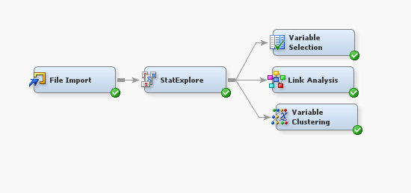

Figure 3.2: Data Exploration in SAS Enterprise Miner

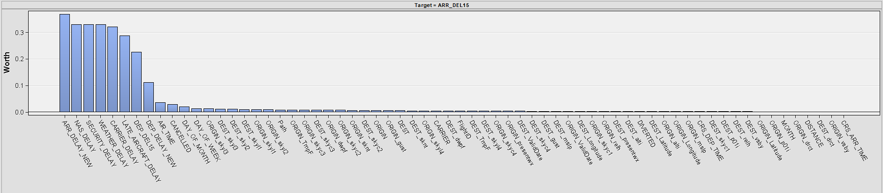

Figure 3.3 Variable Worth Chart